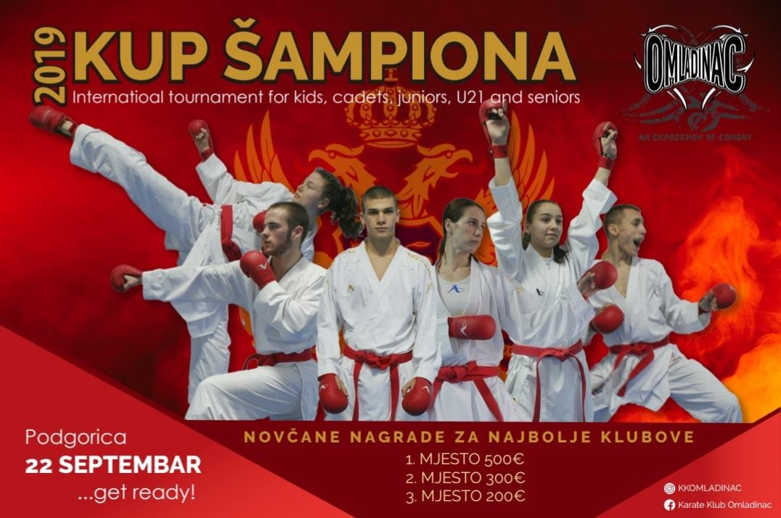

|  |  |  |
| --- | --- | --- |
| Dear sports friends,  We proudly announce that we will organize Champion Cup2019 in Podgorica on 20.September 2019. We are calling you to take part in the best karate championship, with the best competitors in region and the world. Take part and enjoy in professional karate and professional judgment.  Our goal is to show people around the region and the world values of karate and the spirit of members of our karate family. Omladinac family counts several hundred members from all ages. We are calling you to come and be welcomed, to take a challenge, and enjoy.  In world of karate our intention is to write our name in all history books about karate. You are welcomed to take a part in our journey!  Welcome to Champion Cup 2019!  **Omladinac** | Dragi sportski prijatelji,  Ponosno najavljujemo da ćemo organizovati Kup Šampiona 2019 u Podgorici 22. septembra 2019. Pozivamo Vas da uzmete učešće na najboljem karate turniru, sa najboljim takmičarima regiona i svijeta. Pridružite se i uživajte u karate.  Naš cilj je da pokažemo ljudima širom regiona vrijednosti i benefite bavljenja karateom. Omladinac porodica broji nekoliko stotina članova svih godišta. Pozivamo Vas da budete dio spektakla, prihvatite izazov i uživate.  Namjera nam je da ime našeg karate kluba bude sinonim za vrhunski karate.  Dobro došli na Kup Šampiona 2019!  **bg1-2-small.pngOmladinac** | |
|  |  | |
| *Podgorica*,  Placed on the confluence of two rivers - the Moraca, a turquoise-tinged fast flowing river, and the smaller Ribnica is Montenegro’s capital city. The compact Balkan destination it’s certainly full of soul, packed with outstanding art galleries, spell-binding natural beauty, and bustling cafes. | *Podgorica*,  Smještena na ušću dvije rijeke - Morače, tirkizno brzotekuće rijeke, i manje Ribnice je Glavni grad Crne Gore. Kompaktna balkanska destinacija svakako puna duše, prepuna prirodnih ljepota, umjetničkih galerija, , živahnih kafića… | |
| GrbPodgoricev12.png | | |
|  | | |
| ***COMPETITION VENUE*** | ***LOKACIJA DOGADJAJA*** | |
| Moraca Sports Center  ***Adress :*** Ivana Milutinovića, Podgorica, Montenegro  ***Google maps:***[***https://goo.gl/maps/CHMYhm2DFwH2***](https://goo.gl/maps/CHMYhm2DFwH2) | Sportski centar Morača  ***Adress :*** Ivana Milutinovića, Podgorica, Montenegro  ***Google maps:*** [***https://goo.gl/maps/CHMYhm2DFwH2***](https://goo.gl/maps/CHMYhm2DFwH2) | | |
|  | | |
|  | | |
| ***REGISTRATION OF COMPETITORS***  [***https://karate4.me/turnir/32***](https://karate4.me/turnir/32)  latest until  Friday, 20September 2019. until 23:59 hours  For additional information please contact us. | ***REGISTRACIJA TAKMICARA***  [***https://karate4.me/turnir/32***](https://karate4.me/turnir/32)  najkasnije do  petka, 20Septembra2019. do 23:59 sati  Za dodatne informacije kontaktirajte nas. | |
| ***ENTRY FEE***  15€ for individual category  25€ for team category | ***KOTIZACIJA***  15€ pojedinačne kategorije  25€ timske kategorije  bg1-2-small.png | |
| ***SCHEDULE OF COMPETITION***  22.09.2019. Morača Sports Center   |  |  | | --- | --- | | ***Registration & weighing Kumite*** | **7:00 – 09:30** | | *Kata - all categories* | 10:00 | | *Kumite children 5-12 years* | 12:00 | | *Kumite Seniors* | 12:30 | | *Opening ceremony* | 13:00 | | *Kumite Cadets, Junior and U21* | 14:00 | | *Kumite U14* | 15:00 | | *Kumite team* | 16:00 | | ***The announcement of the best club*** | 20:00 | | ***bg1-2-small.png***  ***bg1-2-small.pngRASPORED***  22.09.2019. Sportski centar Morača   |  |  | | --- | --- | | **Registracija & mjerenje Borbe** | **7:00 – 09:30** | | Kate –sve kategorije | 10:00 | | Borbe djeca 5-12godina | 12:00 | | Borbe seniori | 12:30 | | Ceremonija otvaranja | 13:00 | | Borbe kadeti,juniorii U21 | 14:00 | | Borbe U14 | 15:00 | | Borbe ekipno | 16:00 | | **Proglasenje najbolje gkluba** | 20:00 | | |
| ***CATEGORY/ KATEGORIJE*** |
| |  |  |  |  |  |  |  |  |  |  |  |  |  | | --- | --- | --- | --- | --- | --- | --- | --- | --- | --- | --- | --- | --- | |  | **KATE – A** | | | | | | | | | | | | | **Category** | **U8** | **U10** | **U12** | **U14** | | **U16** | | **U18** | | **U21** | | **SENIOR** | | **Year** | 6,7 | 8,9 | 10,11 | 12,13 | | 14,15 | | 16,17 | | 18,19,20 | | 18+ | | **Rules** | \* | WKF | WKF | WKF | | WKF | | WKF | | WKF | | WKF | |  |  |  |  |  | |  | |  | |  | |  | |  | **KATE – B (beginners / pocetnici)** | | |  |  |  |  | |  | | | **Category** | **U8** | **U10** | **U12** | **U14** | |  |  | |  | | | **Year** | 6,7 | 8,9 | 10,11 | 12,13 | |  |  | |  | | | **Rules** | \* | \* | \* | \* | |  |  | |  | | |  |  |  |  |  | |  | |  | |  | |  | |  | **KUMITE MALE** | | | | | | | | | | | | | **Category** | **U8** | **U10** | **U12** | **U14** | | **U16(Cadet)** | | **U18(Junior)** | | **U21** | | **SENIOR** | | **Year** | 6,7 | 8,9 | 10,11 | 12,13 | | 14,15 | | 16,17 | | 18,19,20 | | 18+ | | **Weight** | -30,+30 | -26, -30, -34, -38, +38 | -30, -35, -40, -45, +45 | -40,-45, -50,  -55,+55 | | -52,-57,-63, '-70,+70 | | -55,-61,-68, -76,+76 | | -60, -67, -75, -84, +84 | | -60, -67, -75, -84, +84 | | **Duration** | 1:30minute | 1:30minute | 1:30 minute | 1:30 minute | | 2 minute | | 2 minute | | 3 minute | | 3 minute | | **Rules** | WKF | WKF | WKF | WKF | | WKF | | WKF | | WKF | | WKF | |  |  |  |  |  | |  | |  | |  | |  | |  | **KUMITE FEMALE** | | | | | | | | | | | | | **Category** | **U8** | **U10** | **U12** | **U14** | | **U16(Cadet)** | | **U18(Junior)** | | **U21** | | **SENIOR** | | **Year** | 6,7 | 8,9 | 10,11 | 12,13 | | 14,15 | | 16,17 | | 18,19,20 | | 18+ | | **Weight** | - 28, +28 | -28, -32, -36, +36 | -30,-35,  -40,-45,  +45 | -42,-47,+47 | | -47,-54,+54 | | -48,-53,  -59,+59 | | -50,-55,-61,  -68, +68 | | -50,-55,-61,  -68, +68 | | **Duration** | 1:30 minute | 1:30 minute | 1:30 minute | 1:30 minute | | 2 minute | | 2 minute | | 3 minute | | 3 minute | | **Rules** | WKF | WKF | WKF | WKF | | WKF | | WKF | | WKF | | WKF |   wkf.png***bg1-2-small.png*** | | |
| ***TEAM CATEGORY/ EKIPNE KATEGORIJE*** | |
| |  |  |  |  |  |  |  |  | | --- | --- | --- | --- | --- | --- | --- | --- | |  | **KATE – A** | | | | |  | | | **Category** | **U12** | **U14** | **Cadet/junior** | **Senior** | |  | | | **Year** | 10,11 | 12,13 | 14,15,16,17 | 18 + | |  | | | **Rules** | WKF | WKF | WKF | WKF | |  | | |  |  |  |  |  | |  |  | | |  |  |  |  |  | |  | |  | |  | |  | **KUMITE MALE 3+1** | | | | |  | | | **Category** | **U12** | **U14** | **U16(Cadet)** | **U18(Junior)** | | **Senior** | | | **Year** | 10,11 | 12,13 | 14,15 | 16,17 | | 18 + | | | **Rules** | WKF | WKF | WKF | | WKF | WKF | | |  |  |  |  |  | |  | | |  | **KUMITE FEMALE 3+1** | | | | |  | | | **Category** | **U12** | **U14** | **U16(Cadet)** | **U18(Junior)** | | **Senior** | | | **Year** | 10,11 | 12,13 | 14,15 | 16,17 | | 18 + | | | **Rules** | WKF | WKF | WKF | WKF | | WKF | | | |

***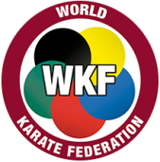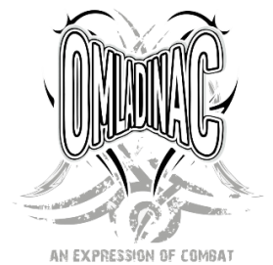  
***

|  |  |
| --- | --- |
| ***RULES / PRAVILA*** |  |
| |  |  |  |  |  |  |  |  | | --- | --- | --- | --- | --- | --- | --- | --- | | **Adjusted rules for children - B** | | | | | | | | | **U8 (5-7 yrs)** | | | Heian/Pinan/Gekisai 1 | | | | possibility to repeat same kata every round | | **U10 (8 - 10 yrs)** | | | Heian/Pinan 1-3, Gekisai 1-2 | | | | | **U12 (10 - 11 yrs)** | | | Heian/Pinan 1-5, Gekisai 1-2 | | | | | **U14 (12 - 13 yrs)** | | | Heian/Pinan 1-5, Gekisai 1-2 | | | | |  |  |  |  |  |  |  |  | | **Official categories for children – A (open)** | | | | | | | | | **U8 (5-7 yrs)** | | | Heian/Pinan/Gekisai 1-2 | | | | repetition of kata every 2nd round | | **U10 (8 - 10 yrs)** | | | WKF rules | | | | Heian/Pinan 1-5, Gekisai 1-2 and all master kata allowed (from WKF official kata list), repetition of same kata not allowed | | **U12 (10-11 yrs)** | | | WKF rules | | | | | **U14 (12-13 yrs)** | | | WKF rules | | | | | **Cadet** | | | WKF rules | | | |  | | **Junior** | | | WKF rules | | | |  | | **U21** | | | WKF rules | | | |  | | **Senior** | | | WKF rules | | | |  | |  |  |  |  | |  |  |  | | **KUMITE** | | | | | | | | | **U8 (5-7 yrs)** | | | WKF rules | | | | duration: 1:30 min | | **U10 (8-9 yrs)** | | | | **U12 (10-11 yrs)** | | | | **U14 (12-13 yrs)** | | | WKF rules | | | | duration: 1:30 min | | **Cadet, Junior,** | | | WKF rules | | | | duration: 2:00 min | | **U21, Senior** | | | WKF rules | | | | duration: 3:00 min | | |
| ***Note:***One year younger competitors can compete in the older category.Competition in A and B categories of the same age is not allowed. Different weight in same age category is not allowed for kumite.Chest protector is mandatory for U8,U10,U12,U14 category for kumite.Only short repechage.  **Note**: Protective equipment (vests) is required.  Competitors are at their own risk. The organizer does not bear any responsibility for injuries. | ***bg1-2-small.png***  ***Napomena :*** Godinu dana mlađi takmičari mogu se takmičiti  u starijoj kategoriji. Nastup u A i B kategoriji istog uzrasta je dozvoljen. Prijava u dvije različite težinske kategorije istog  godišta je dozvoljena za borbe.Štitnik za grudni koš je  obavezan za kategorije U8,U10,U12,U14 borbe.  Samo kratki repasaž.  **Napomena**:Obavezna je oputreba zastitne opreme(prsluci).  Takmicari nastupaju na sopstvnu odgovornost.Organizator ne snosi nikakvu odgovornost za povrede. |
| ***AWARDS*** | ***NAGRADE*** |
| Medals, trophies for team categories, big trophies for best clubs participatory.  ***MONEY AWARDS FOR THE BEST CLUBS:***  ***1 Place 500***€  ***2 Place 300€***  ***3 Place 200€*** | Medalje,pehari za timske kategorije, veliki pehari za najbolje klubske učesnike.  ***NOVČANE NAGRADE ZA NAJBOLJE KLUBOVE****:*  ***1 Mjesto 500€***  ***2 Mjesto 300€***  ***3 Mjesto 200€*** |
|  |  |
| ***CONTAC:*** | ***KONTAKT:*** |
| ***Viber:***  ***Irena Ilincic +38267617619***  ***Mail:***  [***kkomladinac@t-com.me***](mailto:kkomladinac@t-com.me)  ***FaceBook:***  [***https://www.facebook.com/Karate-Klub-Omladinac-388681807983467/***](https://www.facebook.com/Karate-Klub-Omladinac-388681807983467/) | |
|  |  |
| ***OFFICIAL HOTEL - Hotel Ramada Podgorica*** | ***bg1-2-small.pngOFICIJELNI HOTEL - Hotel Ramada Podgorica*** |
| Connected with the popular Mall of Montenegro in the very heart of the capital, the stylish interiors of Ramada Podgorica include a spa area and an elegant top-floor restaurant with panoramic views. Free Wi-Fi and LCD satellite TV are standard in each of its modern-style rooms and suites.  The spacious and luxurious accommodations units at Ramada Podgorica all have individually controlled air conditioning and a mini-bar. The private bathroom comes with bathrobes and slippers.  Ramada Podgorica is just a 15-minute drive from the city's international airport. The Adriatic Sea can be reached in 45 minutes via Sozina Tunnel, while Kolašin Ski Resort is within a 1-hour drive.  BOOKING : <http://www.booking.com/Share-XrQs76> | Hotel Ramada Podgorica je povezan sa popularnim tržnim centrom "Mall of Montenegro" i smješten u samom srcu Glavnog grada. Ovaj otmeno uređeni hotel posjedujespa centar i elegantan restoran na posljednjem spratu,odakle se pruža panoramski pogled. Sve modern sobe i apartmani tipa "suite" uključuju besplatan bežični internet i  LCD TV sasatelitskim kanalima.  Prostrane i luksuzne smještajne jedinice u hotelu Ramada Podgorica sadrže mini-bar i pojedinačno podesi vklima-uređaj. Kupatila u okvir usmještaja sadrže bade-mantile i papuče.  REZERVACIJE : [***http://www.booking.com/Share-kq0Jjc***](http://www.booking.com/Share-kq0Jjc) |
| ***Ramada Logos Vrt ENG RGB_Podgorica.jpg***  ***bg1-2-small.png*** | |
| ***USEFUL INFORMATION*** | ***KORISNE INFORMACIJE*** |
| ***VISA***  Citizens of most EU countries do not need VISA to enter Montenegro. However please check the Ministry of Foreign Affairs of Montenegro website for the latest information on consular affairs:  [www.mip.gov.me/en/index.php/Visas-for-Foreign-Citizens](http://www.mip.gov.me/en/index.php/Visas-for-Foreign-Citizens) | ***VIZA***  Državljani većine zemalja EU ne trebaju vizu da uđu u CrnuGoru. Međutim, ipak predlažemo da provjerite web stranicu Ministarstva spoljnjih poslovaCrne Gore za najnovije informacije:  [www.mip.gov.me/en/index.php/Visas-for-Foreign-Citizens](http://www.mip.gov.me/en/index.php/Visas-for-Foreign-Citizens) |
| ***CURRENCY***  The official currency in Montenegro is Euro .Credit and debit cards are popular in Montenegro and they are accepted in restaurants and hotels.Also, it is easy to find a bank machine that will pay out money from foreign accounts. Banks are open from 08.00 to 20.00h. | ***VALUTA***  Zvanična valuta u CrnojGori je euro (€) .Kreditne i debitne kartice su popularne u CrnojGori i prihvataju se u restoranima i hotelima.Takođe, lako je naći bankomate za isplatu novca sa strain računa. Banke su otvorene od 08.00 do 20.00h. |



**Bošković Bojan**

Svjetskaprvenstva:  
2017.godina – BojanBoskovic, zlatnamedalja, kadet, Spanija

Evropskaprvenstva:  
2018.godina – BojanBoskovic, srebrnamedalja, junior, Rusija  
  
PrveOlimpijskeigremladih:  
PrveOlimpijskeigremladih, 2018.godine, BojanBoskovic, petomjesto, Argentina  
 **Svjetskikup:**

2016.godina – BojanBoskovic, zlatnamedalja, kadet, Hrvatska -Umag

2018.godina – BojanBoskovic, zlatnamedalja, junior, Bugarska -Sofija

2018.godina – BojanBoskovic, bronzanamedalja, junior, Hrvatska –Umag

2019.godina – BojanBoskovic, zlatnamedalja, junior, Hrvatska -Umag

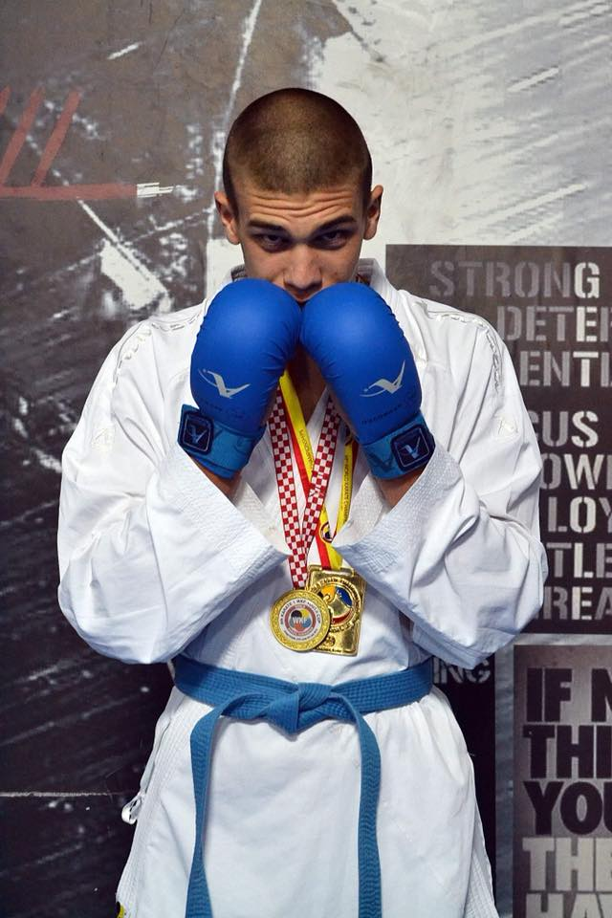

**Jovanović Milena**

Svjetska prvenstva:  
2017.godina – Milena Jovanovic, bronzana medalja, kadet, Spanija  
  
  
Evropska prvenstva:  
2019.godina – Milena Jovanovic, srebrna medalja, juniorka, Danska  
  
**Svjetskikup:**

2017.godina – Milena Jovanovic, srebrna medalja, kadet,Hrvatska-Umag

2018.godina – Milena Jovanovic, 5 mjesto, kadet,Bugarska-Sofija

2018.godina – Milena Jovanovic, 5 mjesto, kadet,Hrvatska-Umag

2018.go

dina – Milena Jovanovic, zlatna medalja ,junior,Italija-Venecija



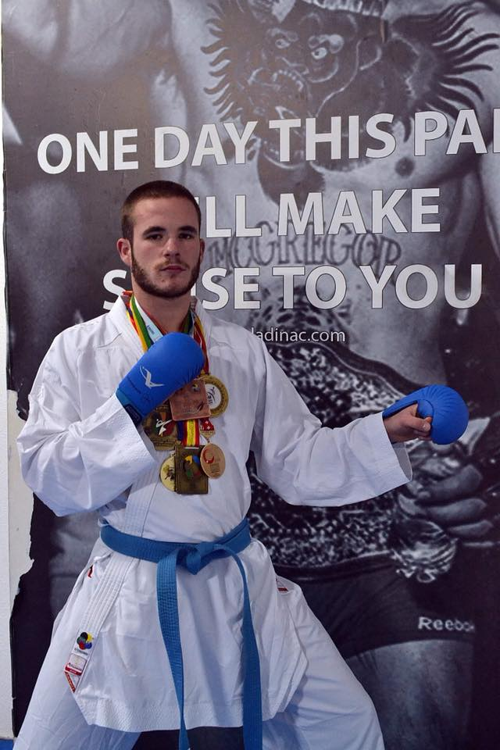**Hodžić Mario**

**Svjetskaprvenstva:**  
2013.godina – Mario Hodzic,zlatna medalja, kadet, Spanija  
2017.godina – Mario Hodzic, bronza namedalja, mladji senior, Spanija  
  
**Evropskaprvenstva:**  
2014.godina – Mario Hodzic, bronzana medalja, kadet, Portugal  
2015.godina – Mario Hodzic, bronzana medalja, junior, Svajcarska  
2016.godina – Mario Hodzic, zlatna medalja, junior, Kipar  
2017.godina – Mario Hodzic, bronzana medalja, senior, Turska  
2018.godina – Mario Hodzic, bronzana medalja, mladji senior, Rusija  
2019.godina – Mario Hodzic, srebrna medalja, senior, Spanija  
  
**EvropskeOlimpijskeigre:**  
Druge Evropske Olimpijske igre 2019.godine,Bjelorusija,MINSK, Mario Hodzic, srebrnamedalja  
 **Evropskoregionalnoprvenstvo 2017.godine, Kosovo**  
Seniori ekipno (Hodzic, Dulovic, Malovic, Jovic, Kukulicic,Popovic), bronzanamedalja  
  
**Premier lige:**  
2017.godine Mario Hodzic, seria A u Salzburgu, brozana medalja  
  
**Svjetski kup:**

2015.godina – Mario Hodzic, zlatna medalja, junior, Hrvatska-Umag

2017.godina – Mario Hodzic, srebrna medalja, mladji senior, Hrvatska-Umag

**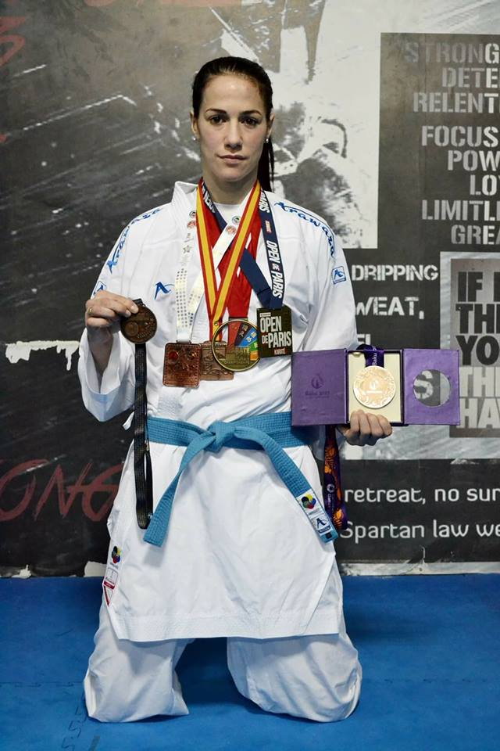Raković Marina**

Svjetskaprvenstva:

2016.godina – Marina Rakovic, bronzana medalja, seniorka, Austrija

Evropskaprvenstva:  
2012.godina – Marina Rakovic, bronzana medalja, seniorka, Spanija  
2013.godina – Marina Rkovic, bronzana medalja, seniorka, Madjarska  
2015.godina – Marina Rakovic, bronzana medalja, seniorka, Turska  
2015.godina – Seniorkeekipno(Rakovic,Draskovic,Konjevic,Maksimovic),petomjesto,Turska  
  
Evropske Olimpijskeigre:  
Prve Evropske Olimpijske igre 2015.godine,Azerbejdzan-BAKU, Marina Rakovic, bronzana medalja

Svjetske igre:  
Svjetske igre 2017.godine, Marina Rakovic, petomjesto, Poljska  
  
Evropsko regionalno prvenstvo 2017.godine, Kosovo  
Seniorke ekipno (Rakovic, Konjevic, Maksimovic) srebrna medalja

Premier lige:  
2016.godina Marina Rakovic, premier liga u Parizu, bronzana medalja  
2016.godina Marina Rakovic, premier liga u Istanbulu, bronzana medalja  
2019.godina Marina Rakovic, premier liga u Dubaiu, bronzana medalja  
2019.godina Marina Rakovic, seria A u Istanbulu, zlatna medalja

**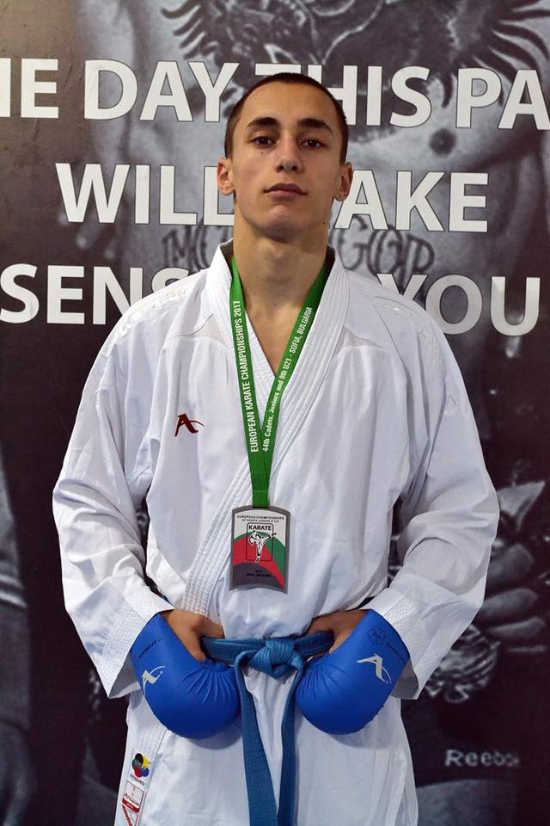Dulović Nenad**

Svjetska prvenstva:  
2015godina – NenadDulovic, petomjesto, junior, Indonezija.  
  
Evropska prvenstva:  
2017.godina – NenadDulovic, srebrna medalja, mladji senior, Bugarska  
2018.godina – NenadDulovic, sedmo mjesto, senior, Srbija  
2019.godina – NenadDulovic, bronzana medalja, mladji senior, Danska  
  
Evropsko regionalno prvenstvo 2017.godine, Kosovo  
Seniori ekipno (Hodzic, Dulovic, Malovic, Jovic, Kukulicic,Popovic), bronzanamedalja  
  
Premier lige:  
2018.godina NenadDulovic, seria A u Salzburgu, srebrna medalja  
2018.godina NenadDulovic, premier liga u Istanbulu, bronzana medalja  
  
**Svjetskikup:**

2014 godina – NenadDulovic, zlatna medalja, kadet, Hrvatska-Umag.  
2015 godina – NenadDulovic, srebrna medalja, junior, Hrvatska-Umag.  
2016 godina – NenadDulovic, zlatna medalja, junior, Hrvatska-Umag.

2018 godina – NenadDulovic, zlatna medalja, U21, Hrvatska-Umag.

2019 godina – NenadDulovic, srebrna medalja, U21, Hrvatska-Umag.

**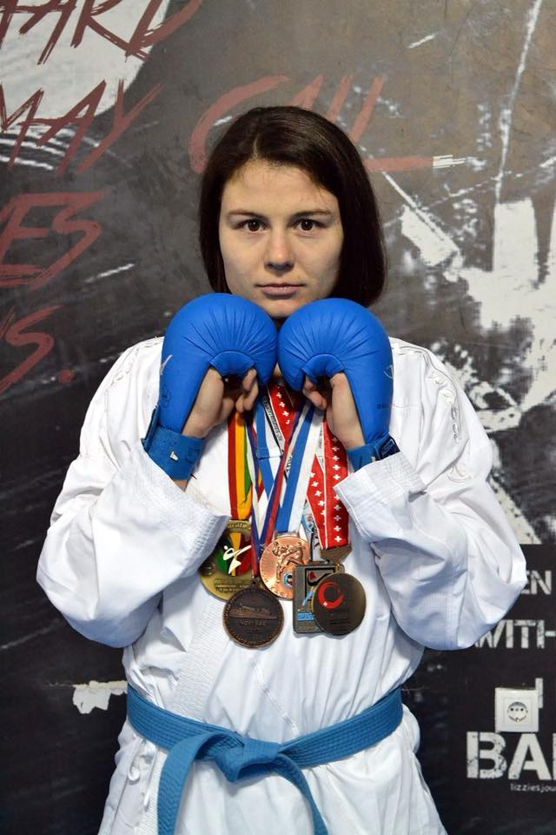Maksimović Jelena**

Svjetska prvenstva:  
2011.godina – JelenaMaksimovic, petomjesto, junior, Malezija

Evropska prvenstva:  
2011.godina – Jelena Maksimovic, bronzana medalja, juniorka, Srbija  
2013.godina – Jelena Maksimovic, srebrna medalja, mladjaseniorka, Turska  
2014.godina – Jelena Maksimovic, bronzana medalja, mladjaseniorka, Portugal  
2014.godina – JelenaMaksimovic, bronzana medalja, seniorka, Finska  
2015.godina – Jelena Maksimovic, bronzana medalja, mladjaseniorka, Svajcarska  
2015.godina – Seniorke ekipno(Rakovic,Draskovic,Konjevic,Maksimovic), petomjesto,Turska  
2019.godina – Jelena Maksimovic, petomjesto, seniorka, Spanija  
  
  
Evropsko regionalno prvenstvo 2017.godine, Kosovo  
Seniorke ekipno (Rakovic, Konjevic, Maksimovic) srebrna medalja

**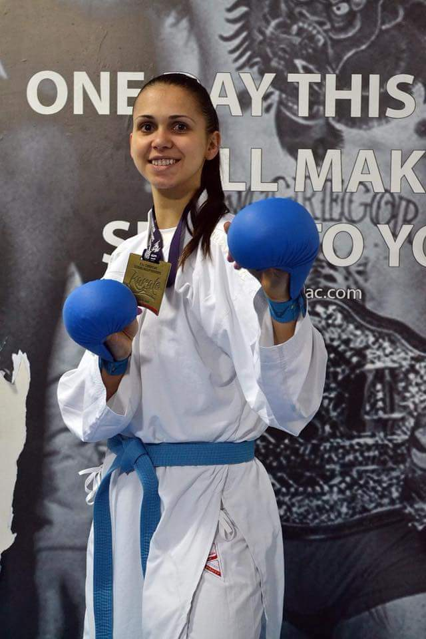Konjević Dragana**

**MEDITERNSKO PRVENSTVO**

2012 god.

DraganaKonjevic - bronza,seniorka - BIH

EkipnoZene - bronza ,seniorke - BIH u sastavu Ana Draskovic,MarinaRakovic,DraganaKonjevic

2014 god.

EkipnoZene - bronza ,seniorke–Crna Gora u sastavuDraskovic, Rakovic,Konjevic,Maksimovic

**SVETSKI KUP**

2013 god.

DraganaKonjevic - bronza,seniorka – Slovenija

2014 god.

DraganaKonjevic - bronza,seniorka – Slovenija

Ekipnoseniorkeborbe -zlato (Rakovic,Maksimovic,Konjevic,Draskovic)

**PREMIJER LIGA –LASKO–SLOVENIJA**

2016 god.

DraganaKonjevic - srebro + 68 kg

**EVROPSKO PRVENSTVO ZA SENIORE - FRANCUSKA**

2016 god.

DraganaKonjevic -bronza+ 68 kg

**15 EVROPSKO REGIONALNO PRVENSTVO ZA SENIORE – PRISTINA –KOSOVO**

2017 god.

Ekipnoseniorkeborbe -srebro - (Rakovic,Maksimovic,Konjevic,Draskovic)

**EVROPSKO PRVENSTVO MALIH ZEMALJA–SAN MARINO-ITALIJA – 28.-30.09.2018**

2018 god- DraganaKonjevic – 1 mjesto –SENIORKE +68kg

**EVROPSKO PRVENSTVO- NOVI SAD- SRBIJA – 19-21.maj**

2018 god.

DraganaKonjevic + 68 kg –seniorka – petomjeto

**PREMIJER LIGA SERIJA A – SPANIJA- 09-11.02.2018**

2018 god.

DraganaKonjevic + 68 kg -seniorka- 7 mjesto

**PREMIJER LIGA – ISTAMBUL 08-10.jun**

2018 god.

DraganaKonjevic + 68 kg -seniorka- 9 mjesto

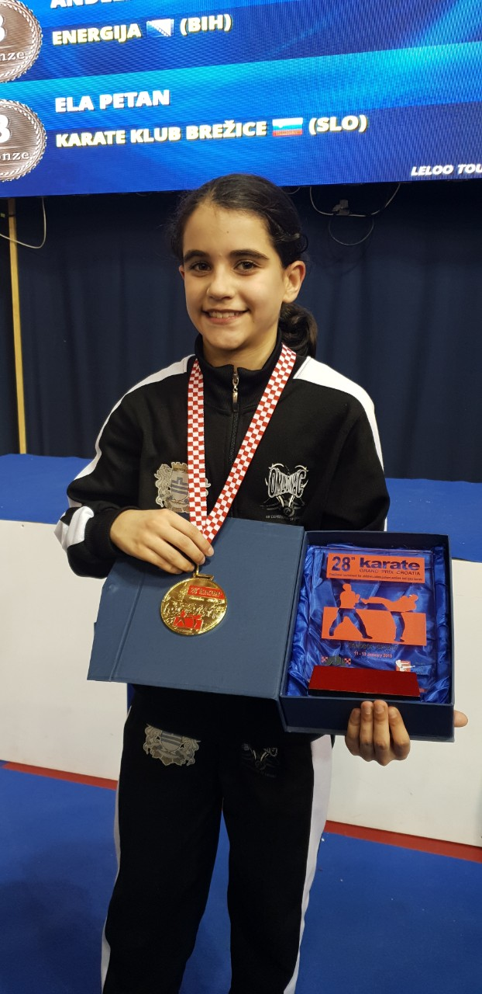

**Helena Backović (2006 god )**

**Balkanske medalje**

2017god. I mjesto(zlato);Turska  
2018god. I mjesto (zlato);Beograd  
2019god. III mjesto(bronza) Banjaluka

**Svjetski Kup Umag**   
2017.III mjesto (bronza)

**Premijer Liga za mlade**

Venecija 2018god.I mjesto (zlato)

Umag 2019god. III mjesto (bronza)

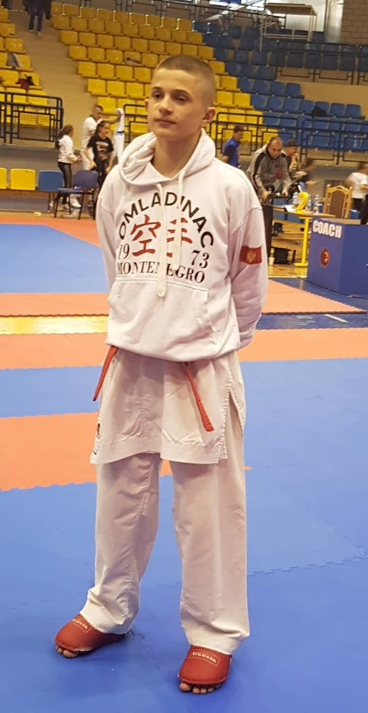

**Saljiu Emre(2005 god)**

**Svjetski kup**

- Umag 2017god. U12 -45. II mjesto (Srebro)

**Balkansko Prvenstvo**

Beograd 2018god. U14 -50 I mjesto (Zlato)

**Premier Liga za mlade**

Umag 2019god. U14 -55 I mjesto (Zlato)

******

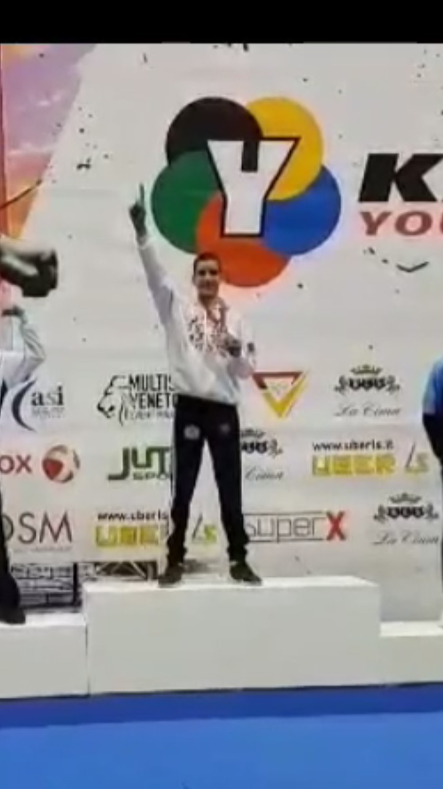

**Andrija Danilovic (2005 god)**

**Balkansko prvenstvo**

2016 god–Beograd-Srbija- srebrna medalja -40 kg  
2017 god - Istanbul –Turska –srebrna medalja -45kg   
2018 god– Beograd- Srbija –srebrna medalja-50 kg

**Premier liga za mlade**2018god. Umag - Hrvatska- zlato U14 -50 kg  
2018god. Venecija – Italija - zlato U14 -55 kg

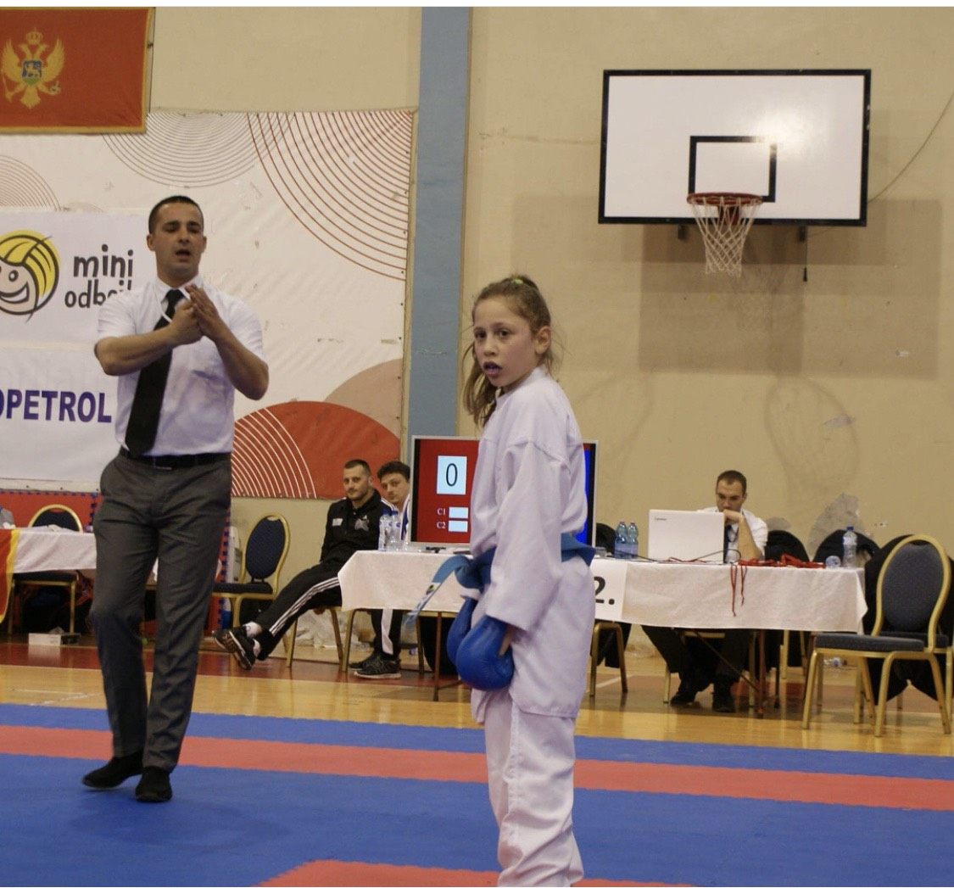

**Una Rakovic (2008 god)**

**Svjetski kup**

2019 god.– srebrna medalja –U12 -40kg Umag-Hrvatska

**Balkansko prvenstvo**

2018 god.–zlatna medalja  - 37 kg  Beograd –Srbija

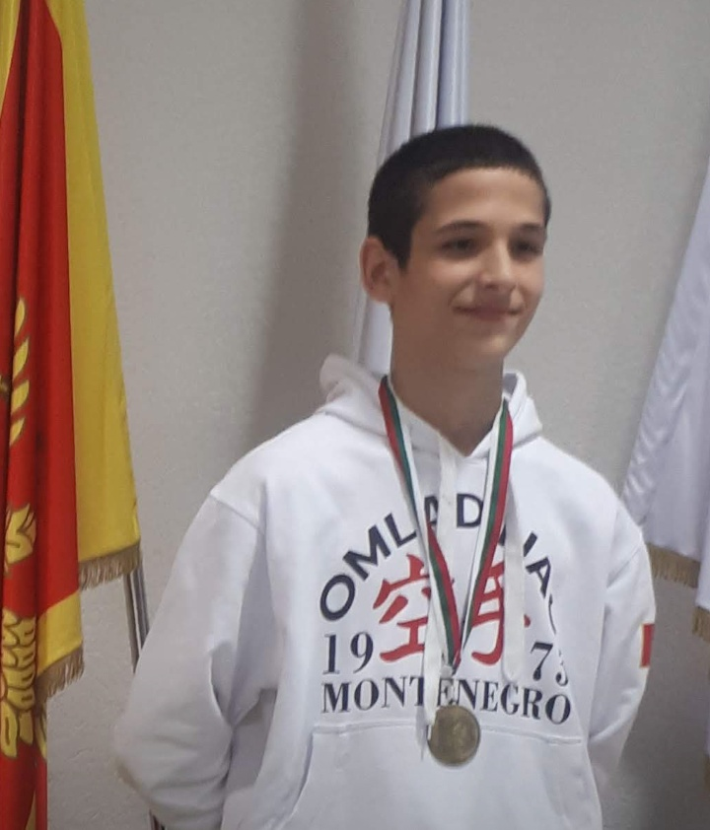

**Vladimir Vukcevic kadet -63kg**

**Balkansko prvenstvo**2017.god - 5.mjesto kategorija-50kg- Istanbul-Turska

2018.god– Dubrovnik-Hrvatska bronzana medalja  - kadet -57kg

**Premier liga za mlade**  
2018.god– Sofija-Bugarska bronzana medalja  U14, -55kg,     
3.

**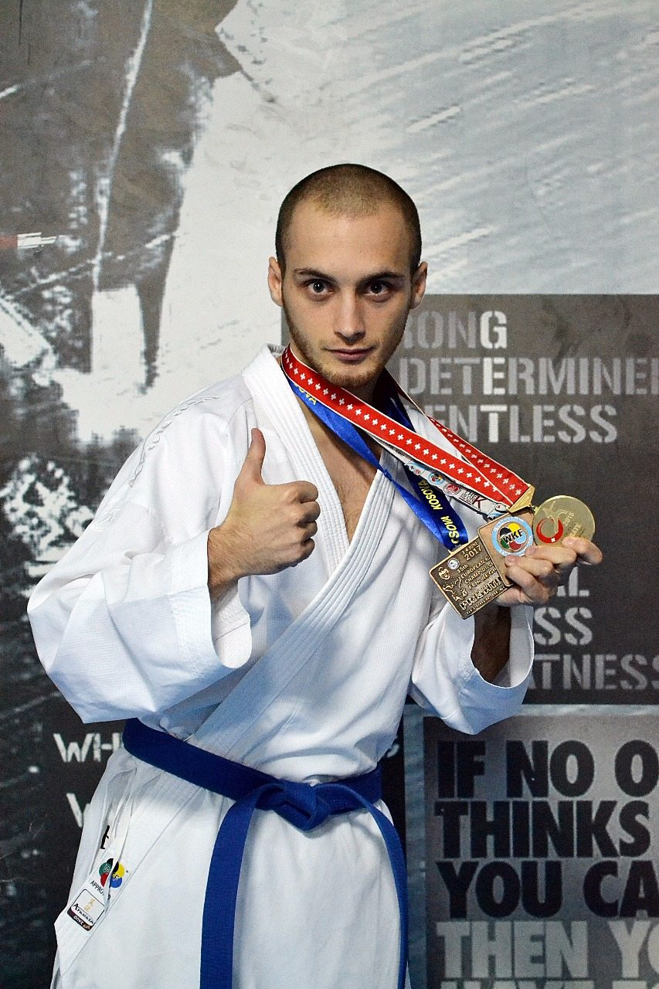**

**Jović Vladimir**

**MEDITERNSKO PRVENSTVO**

2011 god.

Vladimir Jovic - srebro,junior- Italija

**EVROPSKO PRVENSTVO**

2013 god.VladimirJovic– bronza,mladji senior – Turska

2015 god.Vladimir Jovic – zlato,mladji senior – Svajcarska

**15 EVROPSKO REGIONALNO PRVENSTVO ZA SENIORE – PRISTINA –KOSOVO**

2017 god.Ekipno seniori borbe -bronza - (Jovic,Hodzic,Dulovic,Kukulicic,Popovic)

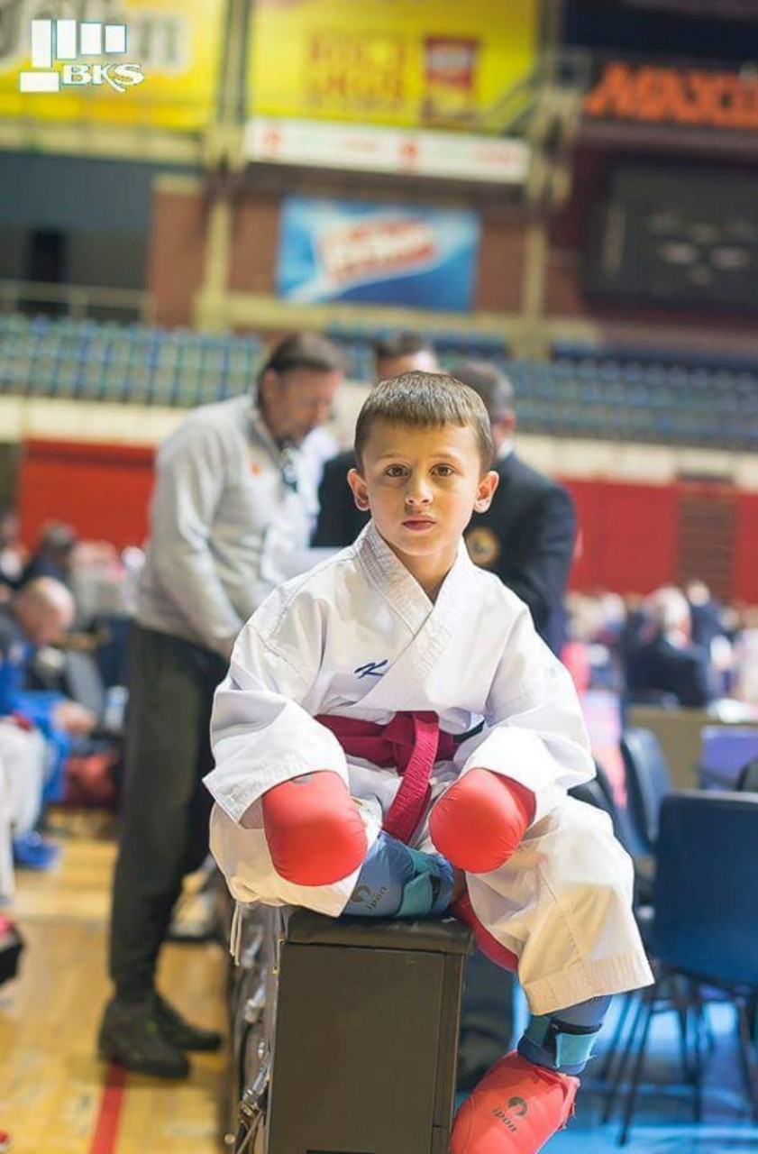

**Jusuf Saljiu 2008 godiste**

**Svjetski kup**

2019  - bronzana medalja U10 -35kg-Umag-Hrvatska

**Balkansko prvenstvo**

2018 - zlatna medalja U10 -30kg -Beograd -Srbija

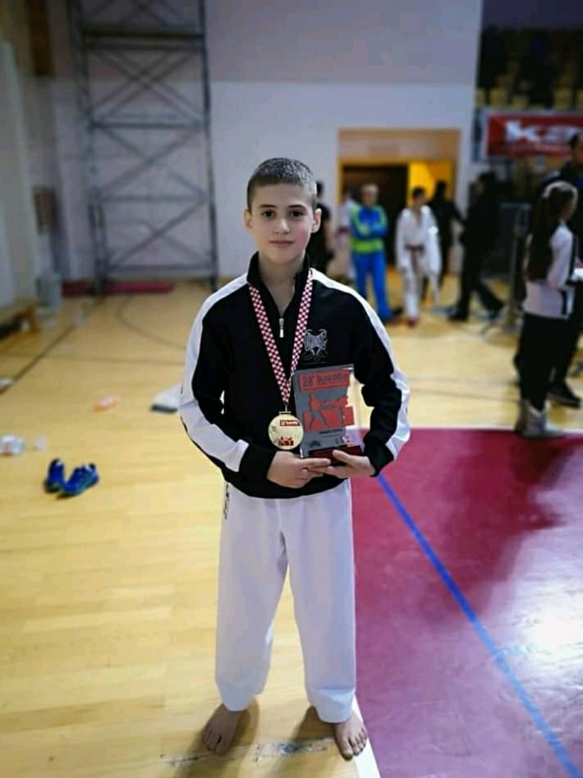

**Ognjen Bjelajac 2005 god -40kg**

**Svjetski kup**

2017 god.– U12-zlatna medalja medalja – 30 kg-Umag –Hrvatska

**Balkansko prvenstvo**

2016 god. za djecu – U12-bronzana medalja – 30 kg-Beograd –Srbija

2018 god.– U14-srebrna medalja- 35 kg -Beograd -Srbija

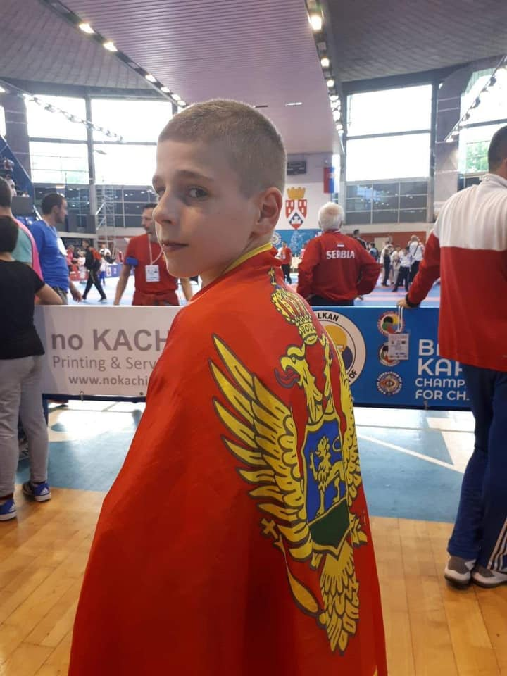**Jovan Fatic (2005 god)**

**Balkansko prvenstvo**

2018 god. za djecu   -Zlatna medalja U14 – 35kg – Beograd-Srbija

**Liga za mlade**

2019 god. Umag bronzana medalja U14 – 50kg

***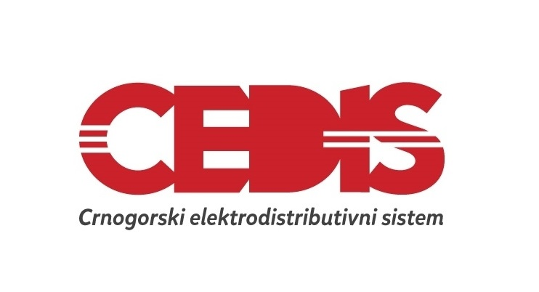***

[***www.cedis.me***](file:///C:\Users\Sladjana\Desktop\takmicenje%202019\www.cedis.me)

***COMPETTION FRIENDS / PRIJATELJI TAKMIČENJA***

***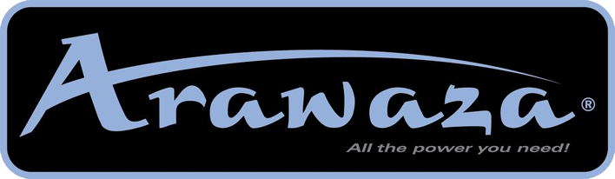***

******

******

**CRNA GORA**